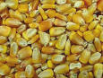
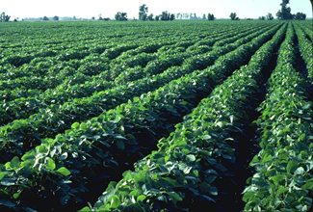
What is Crop Genetic Engineering?
An Introduction to GMOs and Genetic Engineering
Images: USDA

Part 1: Defining Terms

Before starting this project, you should be familiar with these terms and concepts:

- Gene
- DNA
- Protein
- Enzyme
- Genome
- Genotype
- Phenotype
- GMO

Here are some terms and concepts specific to genetic engineering:

Bacillus thuringiensis (Bt) | Soil-borne bacteria which naturally produces the Bt protein toxic to many insects (including European Corn Borer).
Backcross breeding | After a plant has been transformed, the event must be moved into an elite genetic background. This is done by mating the transformed plant back to elite plants over several generations.
Biotechnology | A set of biological techniques developed through basic research and now applied to research and product development. In particular, the use of recombinant DNA techniques.
Bt Corn | Corn that has been transformed with the Bt gene and is resistant to European corn borer.
Elite crop line | Used to describe a highly improved, well adapted breeding line, variety, or hybrid with superior performance.
Genetic engineering | The process of adding foreign DNA to the genome of an organism.
Glyphosate | An herbicide which inhibits the production of amino acids.
Golden Rice | Rice with two genes added to create the production and accumulation of ß-carotene (a vitamin A precursor) in the grain.
Herbicide | A pesticide that kills plants specifically (weeds).
Insecticide | A pesticide that kills insects specifically.
Monsanto | A transnational corporation that produces and markets seeds, genetically modified seeds such as Roundup Ready® seeds, inputs for crop agriculture such as Roundup® and other herbicides, and inputs for animal agriculture such as Posilac®. This is one of the giants in agribusiness.
Organic Farming | A system of farming in which crop and livestock inputs (and to some degree growing conditions) are regulated. GMOs and (most) synthetic pesticides, animal hormones and antibiotics are not allowed in this system.
Pesticide | Any substance or mixture of substances used for controlling, preventing, destroying, repelling, or mitigating any pest. A pesticide also includes any substance or mixture of substances intended for use as a plant regulator, defoliant, or desiccant.
Resistance | The ability of an organism to survive and thrive in the presence of something that would normally cause damage or death (i.e. Roundup Ready Soybeans)
Roundup® | An herbicide that provides non-selective control of several annual and perennial weeds. Roundup will also damage crops, such as corn and soybeans that are not Roundup Resistant. Glyphosate is the active ingredient.
Roundup Ready® | A trade name given to certain varieties of corn, soybean, cotton, or canola which are genetically engineered to be resistant to the herbicide Roundup.
Terminator technologies | A set of transgenes designed to arrest the final stages of seed development in a crop plant. The resulting trait is the production of seeds that will not germinate (sterile). Also called the technology protection system.
Transgene | A gene that has been genetically altered, usually used to transform an organism. Also a foreign gene that has been inserted into the host's genomic DNA.

Part 2: Overview of the Process of Crop Genetic Engineering

Genetic engineering involves inserting of a foreign gene or genes into the genome of another organism. In the process of crop genetic engineering, DNA is removed from one organism (a bacteria for example) and the specific gene of interest is isolated and manipulated so that it can be inserted into the cells of the crop plant. The five steps in the process of crop genetic engineering are described next.
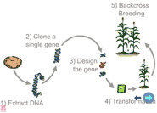

Figure 1. The process of crop genetic engineering. (Copied with permission from Plant and Soil Sciences eLibrary, http://plantandsoil.unl.edu, hosted at the University of Nebraska.)

Step 1: DNA Extraction
Find an organism with a specific trait that you want to add to another organism and extract its DNA.

Step 2: Gene Cloning
Clone the gene that controls the specific trait you are interested in by separating it from the rest of the genes within the DNA that was extracted.

Step 3: Gene Design
Design the gene to produce the desired enzyme (protein) in a specific way in a different organism (the crop plant).

Step 4: Transformation
Insert the gene into the cells of a crop plant. This can be done using a gene gun, agrobacterium, microfibers, or electroporation.

Step 5: Backcross Breeding
Use (traditional) backcross breeding to produce a high yielding crop that exhibits the characteristics of an elite crop line and the desired trait from the transgene. The resultant crop plant is called a GMO, or a genetically modified organism.

Part 3: The Generations of Biotechnology

Crop genetic engineering is a kind of biotechnology. It is used to develop seeds that will produce crops with specific traits. We can describe three generations, or phases, of crop biotechnology.


Generation 1 – Input Trait Control Systems

The first generation of crop biotechnology produced crops genetically engineered to tolerate chemical herbicides or to produce pesticides. Roundup Ready Soybeans and Bt Corn are the most common examples of these crops. Both are widely used today.

Case Study: Roundup Ready Soybeans
Roundup® is a very common glyphosate-based herbicide that is effective in killing a wide range of weed species. It is referred to as a broad spectrum herbicide. Roundup Ready® soybeans are genetically modified crop plants that are resistant to Roundup, and are an example of an herbicide tolerant crop (HTC). Before the advent and wide-spread use of the Roundup Ready technology, weed control options for soybean farmers included (1) in-row cultivation of weeds (tilling), and (2) in-row Roundup (or other herbicide) spray application. In both cases, the farmer had to be careful not to destroy the crop plants in the process of killing weeds in the field. Figure 2 illustrates weed management options prior to Roundup Ready Soybeans. Notice that the soybean plants are planted in rows, and weed management takes place between the rows.

Figure 2. Weed management options for soybean farmers prior to Roundup Ready® technology. Cultivation and application of herbicide (Roundup) done in-row without touching the crop.

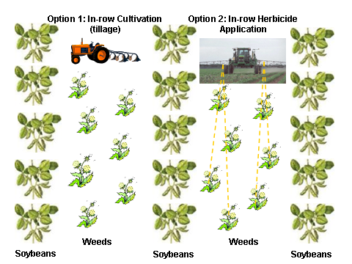

With the advent and availability of Roundup Ready soybeans, farmers can plant the Roundup tolerant crop and spray the entire field including the crop plants with Roundup. The weeds growing the in the field will die, but the crop plants will be unaffected. The terms “conservation tillage” and “no-till” are used to describe this management system, as tilling is reduced or eliminated. Figure 3 illustrates weed management when Roundup Ready soybeans are used. Notice that the crop plants are still planted in rows, but the herbicide can be sprayed over the entire field, not just in between the rows.

Figure 3. Weed management using Roundup Ready soybeans. Roundup herbicide is broadcast sprayed on the entire field, including the crop plants that are resistant.

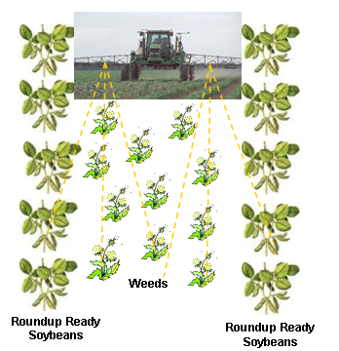

Table 1. Summary of the benefits and concerns associated with Herbicide Tolerant Crops (ie. Roundup Ready soybeans)

Benefits of Herbicide Tolerant Crops | Concerns with Herbicide Tolerant Crops
Broader spectrum of weeds controlled | Yield performance – yield lag and yield drag
Reduced crop injury (from tillage and herbicide application) | Herbicide resistant weeds, aka “Superweeds”
Less herbicide carryover (glyphosate has almost no soil residual activity) | Shifts in weed species from those easily controlled by glyphosate to those more tolerant of it
Price reduction for “conventional herbicides” | Gene escape via pollen drift
Use of herbicides that are more “environmentally friendly” | Gene flow and contamination of organic crops
Crop management flexibility and simplicity, especially in no-till systems | Herbicide drift and non-target movement
Reduction in soil erosion in no-till and conservation tillage systems | World markets and food labeling, including anti-biotech movements in EU and Japan
 | Dependence on Monsanto for seed, technology, and herbicide

Case Study: Bt Corn
Bacillus thuringiensis (Bt) is a naturally occurring soil-borne bacteria that produces a crystalline protein lethal to certain insects. When insects ingest Bt, the crystalline protein paralyzes their digestive tracts, causing them to stop eating. The insects die within 12 hours to 5 days. Bt was formulated as an insecticide spray in the 1950s, and its use is approved for organic farming because it is a “natural” insecticide in the spray form.
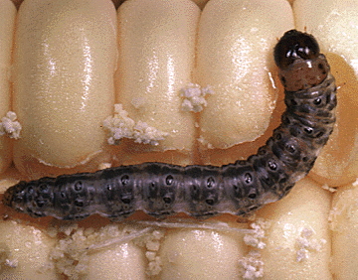
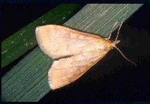

The European corn borer (ECB), a member of the Order Lepidoptera, is a serious pest in corn production. The larvae (caterpillar) stage feeds on corn leaves, stalks, and ears, causing significant economic damage.
ECB Adult Female Moth (Jim Kalisch, University of Nebraska Lincoln, 1995)
ECB larvae (Economic Research Service, USDA)

In 1996, the first Bt corn hybrid was produced using genetic engineering. Scientists isolated the gene coding for one of the Bt proteins toxic to the ECB and inserted into a corn plant. Bt corn, a GMO, produces the crystalline protein that is lethal to ECB larvae. When larvae feed on any tissue of the Bt corn plant, they ingest the protein, their digestive tracts are paralyzed, and they die summarily. Because Bt corn is a GMO crop, it’s use is not allowed for organic farming.

Generation 2 – Output Trait Control Systems

The second generation of crop genetic engineering refers to output trait controls. The slow-rotting tomato that was engineered for longer shelf life is one example. Terminator technology, perhaps the most controversial product of crop genetic engineering, is discussed below.

Case Study: Terminator Technology
Gene drift, or the movement of genes from one plant to another via pollen drift, is a serious concern associated with crop genetic engineering. For example, if a farmer plants Roundup-Ready sunflowers as a crop, cross-pollination might occur between the crop sunflowers and “weed” sunflowers surrounding the field. Because each grain of pollen from the genetically engineered sunflower contains the gene for Roundup resistance, the next generation of “weed” sunflowers produced through cross-pollination would also be resistant to Roundup. This situation not only presents a weed management challenge for the farmer (Roundup won’t kill the “weed” sunflowers), but also raises questions about potential threats to biodiversity as genes placed in crop plants “escape” into nature.

Terminator technology is being proposed by the agriculture industry as a fix for this problem. Terminator plants are genetically modified to produce sterile seeds at harvest. Industry officials claim that Terminator technology will stop gene drift because plants produced via cross-pollination with GM plants that also have the Terminator gene will be sterile, and therefore will not produce seed. Currently, the USDA and Delta & Pine Land (world’s 7th largest seed company) hold a joint patent on the technology, in addition to patents held by Syngenta, DuPont, BASF, and Monsanto. The technology is not yet commercialized or in field trials, though it is being tested in greenhouses in the U.S.

In 2000, the United Nations Convention on Biological Diversity (CBD) placed a de facto global moratorium on the testing and planting of Terminator plants. Their primary concern is the potential affect Terminator will have on biodiversity. If the Terminator gene finds its way into non-crop plants (as the industry claims it will), then the results could be disastrous. Plants would produce sterile seeds, and being unable to produce another generation, could face extinction if left unchecked.

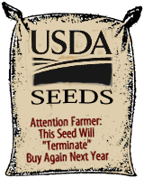
Terminator technology is also challenged because of the threat it poses to global food security. Many farmers in both the global North and the global South rely on seed saving for planting the next year’s crop. Terminator would eliminate this time-honored tradition, and force farmers to pay for seed each year. The industry claims that annual purchase of seed is necessary for them to recover their Research and Development costs, but many farmers simply cannot afford this annual outlay of capital. Several national governments have instituted moratoriums on Terminator plants, and the Union of Concerned Scientists oppose the USDA holding patents on this controversial technology. Additionally, Via Campesina, the international peasant movement, has been active in mobilizing farmers and non-farmers alike in opposing the commercialization of this technology. (Vía Campesina website: http://viacampesina.org/main_en/index.php?option=com_frontpage&Itemid=1)
From Mother Jones, www.motherjones.com/ news/feature/1998/04/bag.gif

Generation 3 – Nutraceuticals, Bioreactors, “Pharm Crops” & “Functional Foods”

The third generation of biotechnology refers to products designed for the food - pharmaceutical retail sector. The products offer perceived benefits for consumers ranging from edible vaccines, anti-cancer vegetables, cholesterol reducing grains, crops fortified with nutrients, and blue carnations.

Case Study: Golden Rice
Dietary vitamin A deficiency is the single most important cause of blindness among children in developing countries, causing 250,000 to 500,000 children to go blind each year. It is also a substantial contributor to illness and death from infectious diseases. The biotechnology industry has responded to these challenges with the introduction of Golden Rice, a GE crop that accumulates provitamin A (ß-carotene) in the grain.

Varied dietary intake, including vegetables, fruits, and some animal products, is the best way for people to avoid micronutrient deficiencies. Because rice is the dietary staple for many in the developing world, Golden Rice has been proposed as a way to circumvent the need for improved diets.

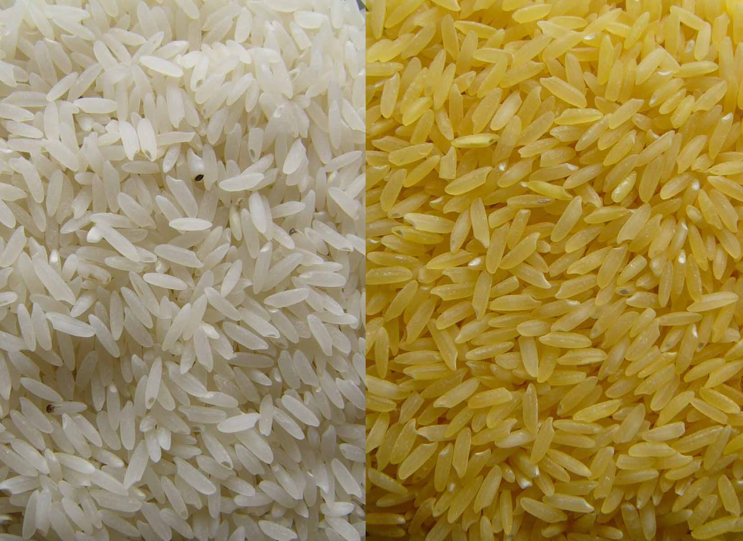
Engineering Golden Rice
ß-carotene (provitamin A) is produced in the green tissues of rice plants, but not in the edible portion of the grain called the endosperm. In Golden Rice, two genes have been inserted into the rice genome to create the production and accumulation of ß-carotene in the endosperm. Golden Rice grains are actually golden in color, indicating the presence of ß-carotene in the endosperm.
Rice
Golden Rice
(Golden Rice Project www.goldenrice.org)

Critics of Golden Rice argue that first, the bioavailability of ß-carotene is quite low, maybe 10% or less. Second, and more importantly, ß-carotene is fat soluble, so digestion, absorption, and transport require a functional digestive tract, adequate protein and fat stores, and adequate energy, protein, and fat in the diet. Many children suffering from vitamin A deficiency, however, are malnourished and/or have intestinal infections that interfere with the absorption of ß-carotene and its conversion to vitamin A. In short, the ingestion of ß-carotene from Golden Rice does not ensure that vitamin A will be absorbed. The key to overcoming micronutrient deficiencies more likely lies in improved and varied diets, and improved socioeconomic status.

Part 4: Extent of GE Crops in the Food System

The first generation of biotechnology, including herbicide tolerant and insect-resistant crops have been most widely adopted. According to the Economic Research Service of the USDA, in 2003 about 167 million acres of these genetically engineered crops were cultivated worldwide, up 15% from 2002. U.S. acreage accounts for 63% of this total.

In 2005 herbicide tolerant soybeans accounted for 87% of all soybeans planted in the U.S. Herbicide tolerant cotton was 61% of cotton acreage in the same year.
Bt cotton was 52% of cotton planted, and Bt corn was 35% of corn planted in 2005.

Given the key significance of corn and soybeans as either feed for livestock or food and food additives for human consumption, GMOs are significant in the food system. According to one estimate, over 60% of all processed foods on the shelves of U.S. supermarkets contain ingredients from soybeans, corn, or canola. High fructose corn syrup (HFCS) is no doubt responsible for much of this, as it is an ingredient in soft drinks, candies, and most processed foods.

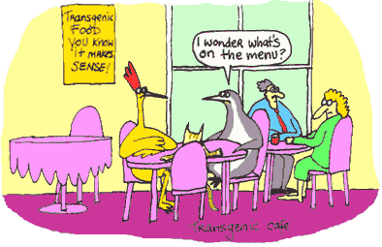
Image from: tiki.oneworld.net/ penguin/genetics/GE9.html
References and Further Information

High School Crop Genetic Technology Website!!
The University of Nebraska has a really useful website with lessons on genetic engineering created specifically for high school students. You can find it at:
http://citnews.unl.edu/hscroptechnology/index.html

Plant and Soil Sciences elibrary
The University of Nebraska also hosts the Plant and Soil Sciences elibrary. Lessons and animations are searchable by level, and specific lessons are designed for use with high school students. You can find it at:
http://plantandsoil.unl.edu/croptechnology2005/pages/index.jsp

Glossary
Pew Initiative on Food and Biotechnology has a useful glossary available at: http://pewagbiotech.org/resources/glossary/

This material was developed through the Cornell Science Inquiry Partnership program (http://csip.cornell.edu), with support from the National Science Foundation’s Graduate Teaching Fellows in K-12 Education (GK-12) program (DGE # 0231913 and # 9979516) and Cornell University. Any opinions, findings, and conclusions or recommendations expressed in this material are those of the author(s) and do not necessarily reflect the views of the NSF.

