Handout #4
PLATE DESCRIPTION, COLONY MORPHOLOGY
AND BACTERIAL ISOLATION

Imagine you are a bacterium on the surface of the carrot. Someone comes in with a swab and snatches you up (OH NO!). But wait……it isn’t so bad! This nice person just deposited you on a very cushy surface, full of yummy nutrients which you can use for all of your life processes, including reproduction.

Bacteria reproduce via a process called binary fission. In this process the bacteria replicates its chromosome, and then the cell divides in two. Then those cells divide in two and so on and so on until you have many bacteria!!!!!!!
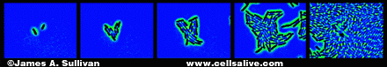

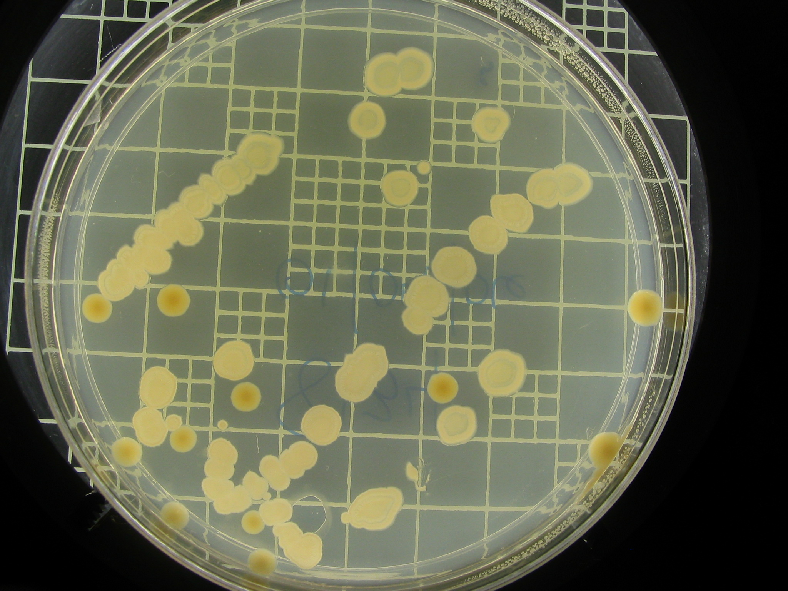
After many, many divisions and when grown on a solid surface such as the LB media in your Petri dishes, the bacteria are visible to the naked eye in a structure called a colony. The colonies that you see on your plates all arose from one bacterium! Its pretty amazing that these are visible to the naked eye, since an average bacteria is between 1 -3 microns in length (remember that a micron is 1/1000 of a millimeter.

Colonies can be described based on their morphology, or shape. On the next page are pictures of different types of colony morphologies. Do any of your colonies on the LB plates have these morphologies? Which types of morphologies are represented on your LB plates? What colors are your colonies? Are they dry looking, or wet looking. Some microbiologists use the term “mucousy” to describe colonies because they look like snot. In the space below describe the colonies on your LB plates:
DILUTION PLATE: __________________________________________
____________________________________________________________________________________________________________________________________________________________________________________________________________________________________
CARROT PLATE: ____________________________________________
____________________________________________________________________________________________________________________________________________________________________________________________________________________________________

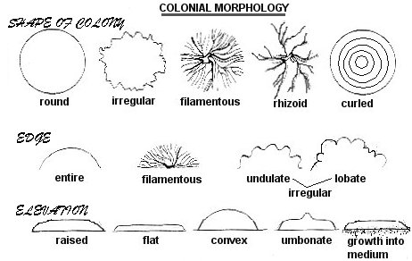

Fungal reproduction is much more complex, but many fungi still form colonies. Look at your SDA plates and describe the colony characteristics.
DILUTION PLATE: __________________________________________
___________________________________________________________________________________________________________________________________________________________________________
CARROT PLATE: ____________________________________________
____________________________________________________________________________________________________________________________________________________________________________________________________________________________________

On the last page you will find an area to sketch each of your plates.

BACTERIAL ISOLATION: Now that you have described the colonies on your LB plate, you may notice that they look very different from one another. Chances are that each unique colony type represents a unique bacterium. In order to better understand who was doing the decomposing in your microcosms, we are asking you to isolate or separate an individual type of bacteria on another LB plate.

- Identify two (2) unique colony morphologies on your LB plates. One can come from the dilution plate, and one from the carrot plate, or they can both come from the dilution or carrot plate. Just make sure that they each have some distinguishing characteristic like different colors, or different colony morphologies.
- Circle each colony on the bottom of your Petri dish. Label one “Colony #1” and the other “Colony #2”.
- Next, label the two (2) LB plates with your initials, and the date. On one write “Colony #1” and on the other write “Colony #2”. Remember to write on the edge of the plate so you can visualize the colonies after they grow.
- Take your tinfoil package containing your sterile swabs and carefully open it up on the end with the tape.
- Carefully remove a sterile swab, and crack the cover of the Petri dish that has your “Colony #1” on it.
- Gently touch the swab to “Colony #1” being careful to avoid touching other colonies. REMEMBER WE WANT TO ISOLATE ONE TYPE OF BACTERIA!
- Streak the fresh LB Plate that you labeled with “Colony #1”. Use the diagram below as a guide.

- Place the swab in the plastic bag provided at your station being careful not to touch ANYTHING ELSE.
- Repeat these steps for “Colony #2”.
- IMMEDIATELY WASH YOUR HANDS WITH SOAP AND WATER.
- Let your teacher know when you are done so she or he can collect the plates and used swabs for safe disposal.

