The Wrath of the Rotting Root

Teacher’s Guide

by Jenna Mendell, CSIP Graduate Student Fellow, Cornell University

Overview
Decomposition is defined as the breaking down of a substance into a less complicated chemical structure. The decomposition of organic material is critical in maintaining the planet, and its atmosphere, as we know it. This activity will allow students to design an experiment to look at how different factors affect the rate of decomposition of organic material (a carrot), isolate the bacteria and fungi responsible for its decomposition, and assess various biochemical abilities of these organisms.

Subject
Biology, Microbiology, Ecology

Audience
High School or Middle School

Time Required
Dependent upon how many parts of the activity you choose to do.
Day 1 (preferably a double period): Introduce the process of decomposition, brainstorm about factors that could influence the rate of decomposition, develop data collection/recording sheet, and complete experimental design.
Day 2: Set up microcosms, take initial masses of carrots and microcosms (in case carrots decompose too quickly, students can mass the microcosm and still collect data over several weeks), make baseline observations, review data collection procedure.
Bi-weekly or weekly as time allows: Have students mass their carrots and microcosms. Students should be making physical observations of the carrot (smell, texture, appearance) and also thinking about why they are seeing a change in mass over time (whether this is a gain or loss of mass).
After the carrot has started to decompose: Have students isolate bacteria and fungi on the carrot surface by swabbing it with a sterile swab. Have the students set up a serial dilution to isolate the bacteria and fungi from the soil.
2-3 days after bacterial and fungal isolation: Have students describe the colony morphology (shape) of the different bacteria and fungi they have isolated. They should talk about the color, size, shape, edge, elevation and texture of the colonies. Based on unique colony morphology, have the students isolate two different bacteria from their original bacterial isolation plates.
2-3 days after isolating 2 separate bacteria: Have a brainstorming session about what a carrot is made up of and how that could influence the types of enzymes the decomposing bacteria could possess. Discuss the environment these organisms are found in, and the advantage of being able to exploit a wide variety of resources, such as dead bacteria. Have the students come up with hypotheses about the different biochemical tests. Have the students inoculate the biochemical tests.
2-3 days after inoculating the biochemical tests: Have the students read the tests, record the results and see if their hypotheses were correct. If they were not, have them speculate why.

Background
A leaf falls from a tree in the forest. It settles on the ground, but it doesn’t remain there forever. It eventually breaks down, or decomposes into something that you no longer recognize as a leaf. There are many things that can influence the rate at which the leaf decomposes. In a tropical rainforest where it is hot and moist, leaves and other organic matter decompose at a much faster rate than in a dry temperate region. Things like temperature, moisture, wind, and other environmental conditions are considered abiotic factors. Biotic factors can also influence the rate of decomposition. The visible changes to the leaf can be the result of insects, worms, birds, or other animals feeding on it. However, the final decomposition of the leaf is carried out by bacteria and fungi, which feed on dead tissue. Without these organisms, the planet would become littered with dead and decaying material. The animals, birds, insects, and worms simply would not be able to keep up with the amount of material that needs to be decomposed. In addition, the fungi and bacteria convert the organic matter into material that is usable by plants and other primary producers, helping to maintain the atmosphere of our planet as we know it. This process, called nutrient cycling, is essential to preserving life on earth!

Learning Objectives
1. Students will be able to develop a research question and design an experiment to address this question.

2. Students will be able to identify the independent and dependent variable of their experiment.

3. Students will be able to accurately collect and record quantitative data, and make and record qualitative observations.

4. Students will be able to interpret the data they have collected to determine if their hypothesis is correct.

5. Students will be able to come up with some reasons why their hypothesis was or was not correct.

6. Students will be able to grow bacteria and fungi responsible for decomposition of their carrot.

7. Students will identify an individual bacterium based on colony morphology and other observations. Students will isolate this bacterium, and use it to inoculate biochemical tests to assess the metabolic capabilities of the bacterium.

8. Students will interpret their biochemical tests to identify what enzymes their bacterial isolates possess. The students will relate this to the composition of the carrot and the environment in which the bacteria came from.

NYS Science Education Standards Addressed

Standard 1: (High School and Middle School):
Key Idea 1: The central purpose of scientific inquiry is to develop explanations of natural phenomena in a continuing, creative process.
Key Idea 2: Beyond the use of reasoning and consensus, scientific inquiry involves the testing of proposed explanations involving the use of conventional techniques and procedures and usually requiring considerable ingenuity.
Key Idea 3: The observations made while testing proposed explanations, when analyzed using conventional and invented methods, provide new insights into phenomena.
Performance Indicator 5.1 (Middle school):
Compare the way a variety of living specimens carry out basic life functions and maintain dynamic equilibrium
Key Idea 5 (High School): Organisms maintain a dynamic equilibrium that sustains life.
Performance Indicator 7.1 (Middle School): Describe how living things, including humans, depend upon the living and nonliving environment for their survival.

National Science Education Standards Addressed
Science as Inquiry
- Abilities necessary to do scientific inquiry
- Understandings about scientific inquiry
Life Science
- Interdependence of organisms
- Matter, energy, and organization in living systems
Earth and Space Science
- Geochemical cycles
Science and Technology
- Abilities of technological design
- Understandings about science and technology
Science in Personal and Social Perspectives
- Environmental quality
- Science and technology in local, national, and global challenges

Assessment Strategy

1. Given the appropriate background information on experimental design, and factors that could affect the rate of decomposition, students will complete the experimental design sheet. Students will be assessed by their ability to collect and analyze the data they obtain over time. Students should be able to identify whether their hypothesis was correct, and provide some explanation of this outcome.

2. Given the appropriate background information on bacterial growth and colony morphology, students will successfully identify and isolate an individual bacterium. Students will be assessed by having a single bacterial species on each of their agar plates.

3. Given the appropriate background information on the biochemical tests, students will successfully inoculate these tests. Students will be assessed by their ability to correctly interpret the tests and accurately describe what kind of biochemical processes their bacteria are able to carry out.

For other specific assessment strategies of learning objectives, please refer to the Learning Objectives section.

Teaching Tips

Day 1: (Handout #1) Give a short presentation on decomposition (make sure that the students know what decomposition is!). Explain the difference between abiotic and biotic forces. During the brainstorming session, have students come up with different forces that could influence the rate of decomposition. Break them up into groups and have them come up with several hypotheses. Once they have decided on the one that they as a group want to test, have them come up with an experimental design to test that hypothesis. You may want to have them formally write this up, to reinforce writing and communication in science. This will also give you a chance to review the experimental design and make sure that they have a clear question to answer and have identified the independent and dependent variable. You may want them to think about data collection while they are coming up with their experimental design, and come up with some sort of data collection sheet. Make sure that everyone in the group records the data! Inevitably, if only one person has the sheet, it will get lost. If this happens for some reason, make sure to have “dummy data” so that the students have something for analysis.

Day 2: If the students haven’t already done so, have them design a data-recording sheet (See Sample Data Collection Sheet). Have the students set up their microcosms (a chunk of some hard root vegetable, such as carrot, parsnip, or potato, buried in 1 ¾ cup dirt in zip type plastic baggie), making sure that they weigh both the carrot, and the microcosm in its entirety. They may also want to make some baseline observations of the texture, color and smell of both the carrot and the soil. Additional observations may include the moisture content of the soil and presence of organic matter or macroscopic organisms (if using soil from a garden or other outdoor site). If possible, have the studnets set up their experimental and control microcosms in triplicate. Ask them to write a short explanation of why it is useful to run experiments in triplicate.

Bi-weekly or weekly as time allows: (Handout #2) Have the students weigh their microcosms, record the weight, and calculate the change in mass. After they have weighed the microcosm in its entirety, have the students carefully remove the carrot from the bag, gently remove as much dirt as possible, weigh the carrot, record the weight of the carrot and calculate the change in mass. Have them make qualitative observations. Have them think about what is happening to their carrot. If they see an initial gain in weight, why could this be happening? Why could they see different results when they weigh the entire microcosm vs. the carrot? As time progresses and the carrots decompose even further, ask them why carrots don’t decompose in the ground where they grow. If you would like, you could end the activity here and have them write up a formal lab report on their findings.

After the carrot has started to decompose: (Handout #3) If you are able to get the supplies, then you can have the students isolate bacteria and/or fungi from the carrot surface, and/or the soil on solid agar media. Bacteria are not picky and will grow on many types of media including LB (Luria-Bertani) and NA (Nutrient Agar). To isolate the fungi, there is a special media called SDA (Sabouraud Dextrose Agar) that has a low pH, which will select for the fungi.

2-3 days after bacterial and fungal isolation: (Handout #4) Since these are soil organisms, you can incubate these plates at room temperature for 2-3 days and have beautiful growth. You can also have the students note changes over time as the slower growing could take 7-10 days to appear on the plate. The organisms that you isolate will be affected by the experimental conditions of the microcosm, but the variety is astounding as you can see in the following two pictures.

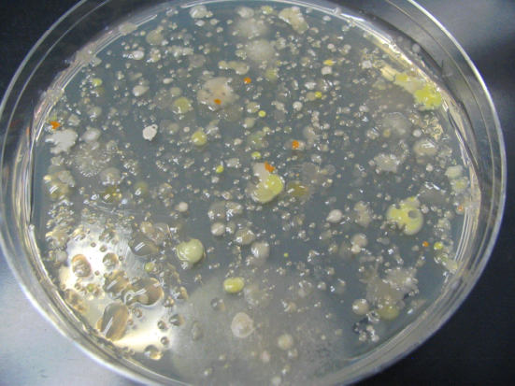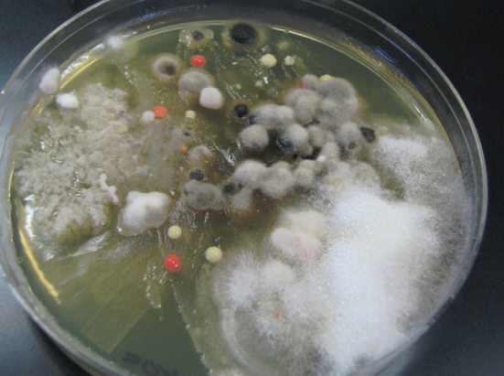
Bacteria isolated from carrot surface Fungi isolated from carrot surface
using LB media. using SDA media.

Have the students describe what the colonies look like, smell like, etc. (see Handout #4 for colony morphology (shape) descriptions). Encourage them to be creative. Tell them to pretend that they are describing this to a friend on the phone. What are some of the adjectives they would use?? You could stop the activity here, if you wish.

NOTE: The vast majority of bacteria and fungi that are isolated are harmless to humans, and are organisms that we come into contact with on a daily basis. However, to minimize exposure it is best to tape the plates shut, and make sure that the students wash their hands after handling them.

If you chose to continue on, have the students isolate an individual bacterium based on colony morphology. To ensure student safety, you may want them to wear gloves. Have them chose a bacteria that is separate from others. See example below:

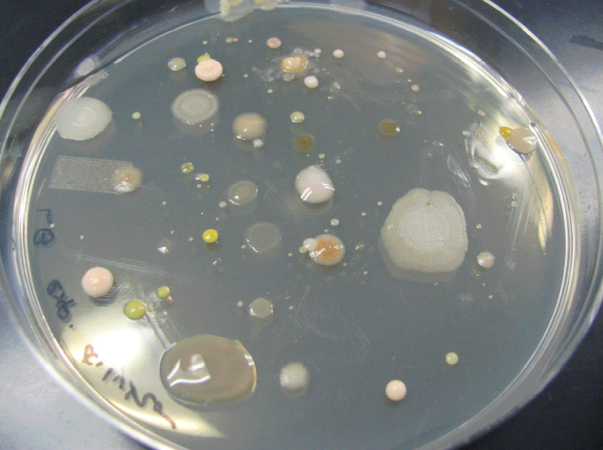
Either of these colonies would be good examples of colonies to use to isolate an individual bacterium.

2-3 days after isolating 2 separate bacteria: (Handout #5 and #6) Have another brainstorming session about the different macromolecules that make up a carrot. You may need to guide them with this activity. You want them to come up with sugar, starch and anything else (since you will be testing for glucose and sucrose fermentation and starch hydrolysis). Also discuss the environment that the carrot is found in, and how it can be very nutrient poor. Although many people think of the soil as nutrient rich, when in reality, it isn’t. I use the example of what happens when a heavy rain falls and percolates down through the soil – it washes the nutrients away. Introduce the concept of DNase – they should recognize the –ase ending as belonging to an enzyme, and facilitate a discussion about having different enzymes to exploit resources in the environment, like the DNA from other bacteria that may die.

Safety

Make sure that students wash their hands with soap and water after handling the plates and inoculating the media. After students have swabbed their plates, or inoculated the biochemical tests, have them place their swabs in a zipper type plastic bag. Make sure that they know not to touch their skin, or their lab mates with the swabs. Swabs can be disposed of in the trash. Agar media plates should be autoclaved or incinerated after use.

Extensions

- Have students develop and implement an “in-house” composting program. Based on the results of their decomposition experiment, ask them to come up with the optimum conditions for composting.

- Have students design a regulation pathway of the dnase gene. Let them be creative with possible regulation strategies of this gene (ie- positive vs. negative regulation).

- Give each group a large piece of paper, and ask them to design a concept map at the end of the activity. Ask them to apply the concepts they leaned in this activity to other activities……you may be amazed at the connections that they make!

This material was developed through the Cornell Science Inquiry Partnership program (http://csip.cornell.edu), with support from the National Science Foundation’s Graduate Teaching Fellows in K-12 Education (GK-12) program (DGE # 0231913 and # 9979516) and Cornell University. Any opinions, findings, and conclusions or recommendations expressed in this material are those of the author(s) and do not necessarily reflect the views of the NSF.

