A Key to
Some Interesting Creatures From Kingdom Protista

The Kingdom Protista contains both one-celled and multi-celled organisms. They are VERY small – most can not be seen without a microscope. They live in aquatic habitats (water) and most eat bacteria, other small organisms or particles they find in the water with them. A few protists can make their own food – these are known as algae. You will probably not find all of these protists in your pond water, but take a close look at your slide – you may see one of the organisms pictured below. These amazing little creatures are often quite fast and may swim out of your sight – so keep a close eye on your microscope!

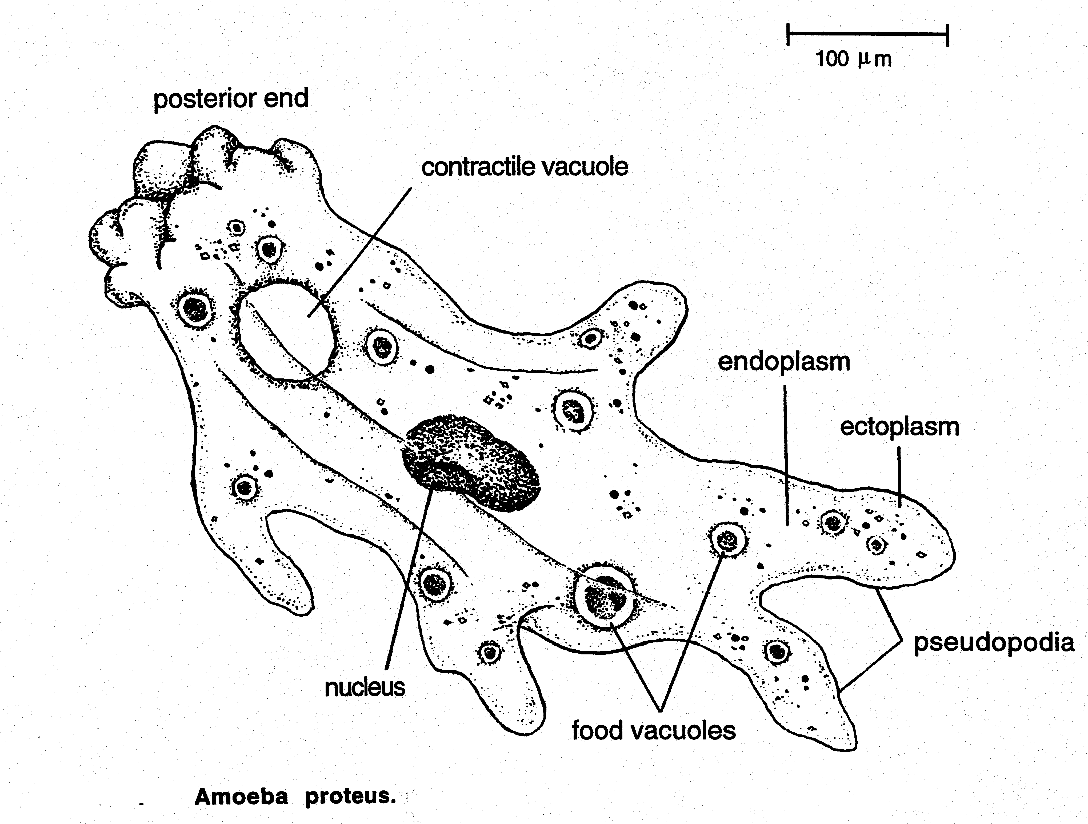
AMOEBAS: Amoebas are oddly shaped protists that move by extending parts of their body as little feet (pseudopods) and then pulling the rest of the body behind. They eat by surrounding a piece of food with their pseudopods and then taking it into the inside of their bodies where it is slowly digested. Note the round food containers inside of the amoeba above. Some amoeba are parasites that can live in larger animals (like us!) and make them very sick.
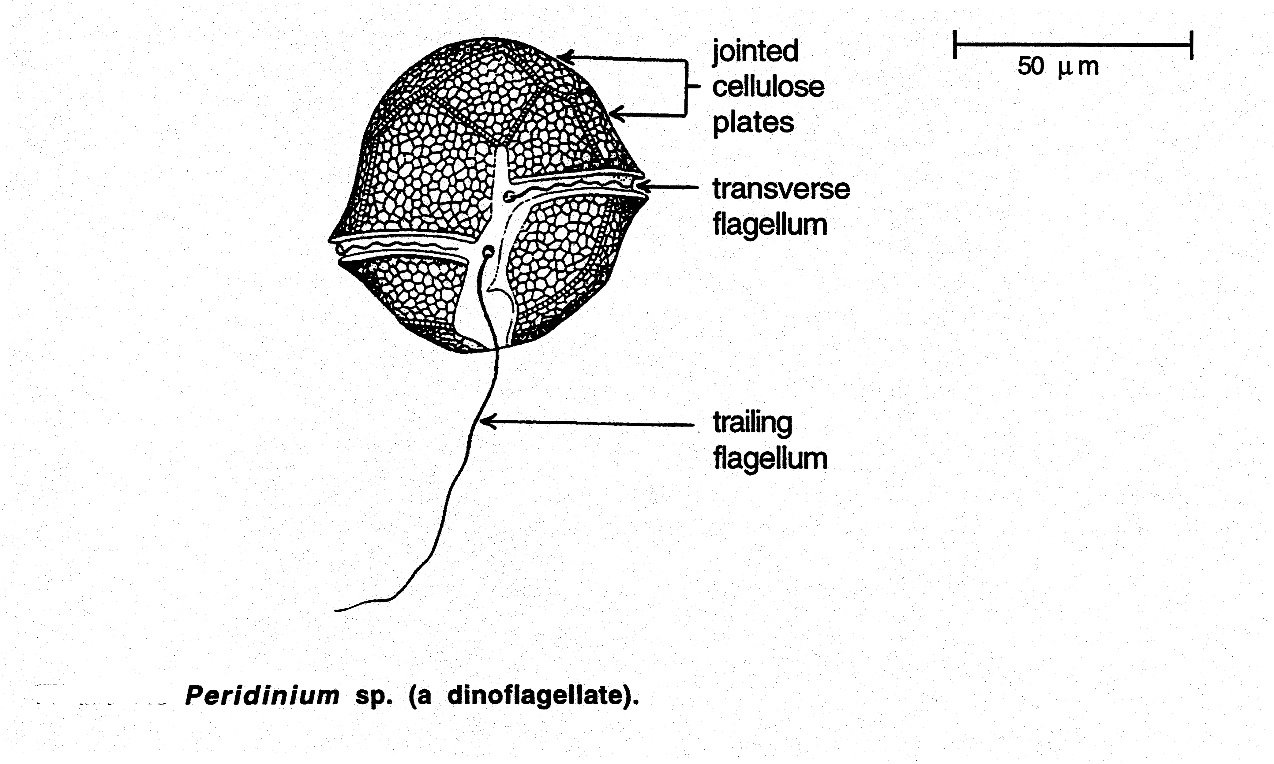
DINOFLAGELLATES: Dinoflagellates are a type of algae that can make their own food like plants. They move with little whips called flagella that they swing like propellers through the water. They have hard cell walls like armor surrounding their body. Sometimes the number of these creatures becomes so great in the ocean that it makes animals in the water (like fish and people) very sick. This is called “red tide” because the dinoflagellates are brownish and turn the water red.

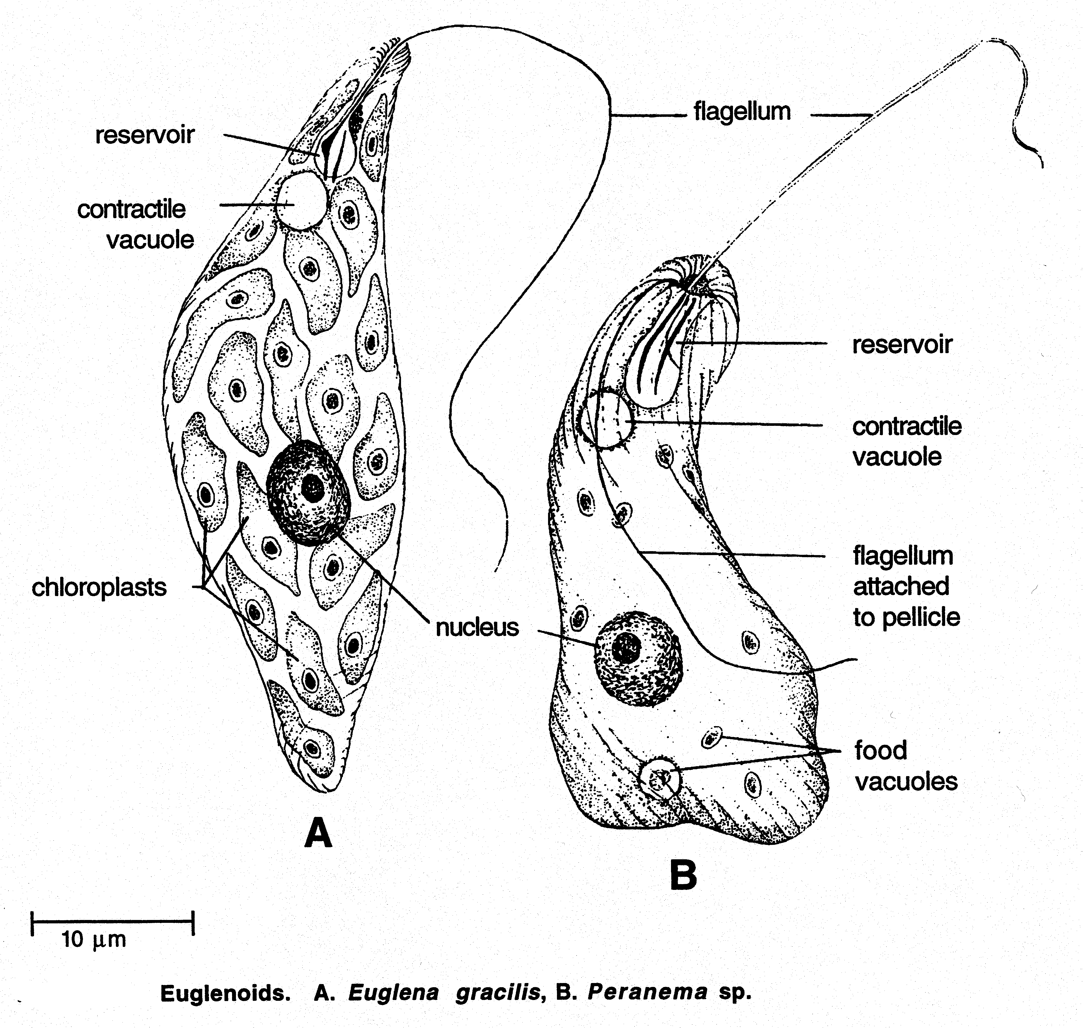
EUGLENAS: Euglenas are protists that move with little whips called flagella that they swing like propellers through the water. Some are green, like plants, and can make their own food. They have an “eyespot” which can detect light and dark like a very simple eye.

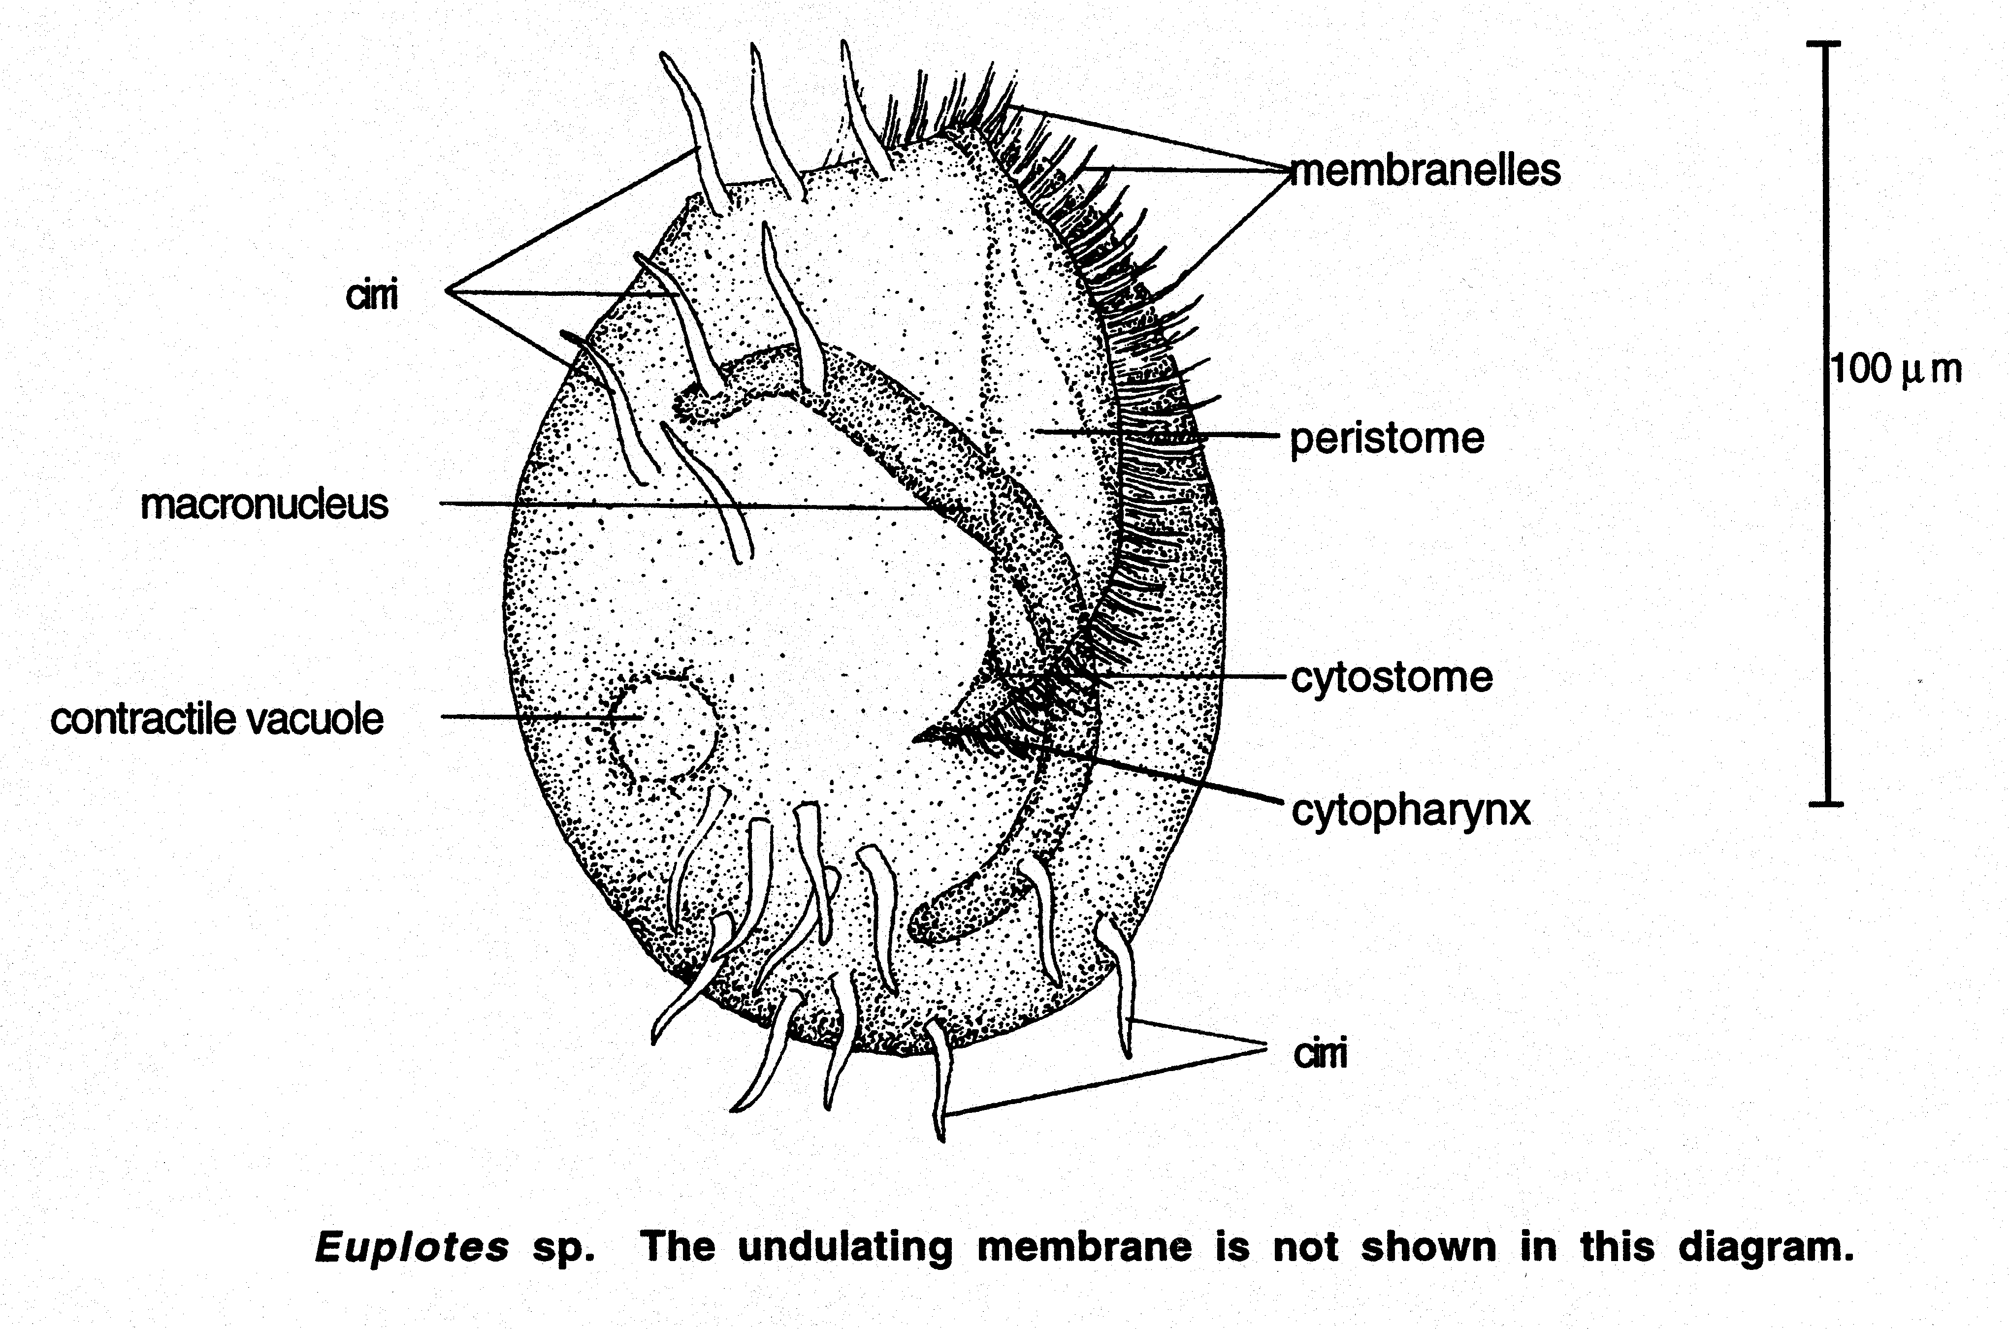
EUPLOTES: Euplotes are protists with little “legs” called cirri that they use to swim or “walk” on things. They also have some tiny “hairs” called cilia that they wave to bring food into their bodies by making a small current.
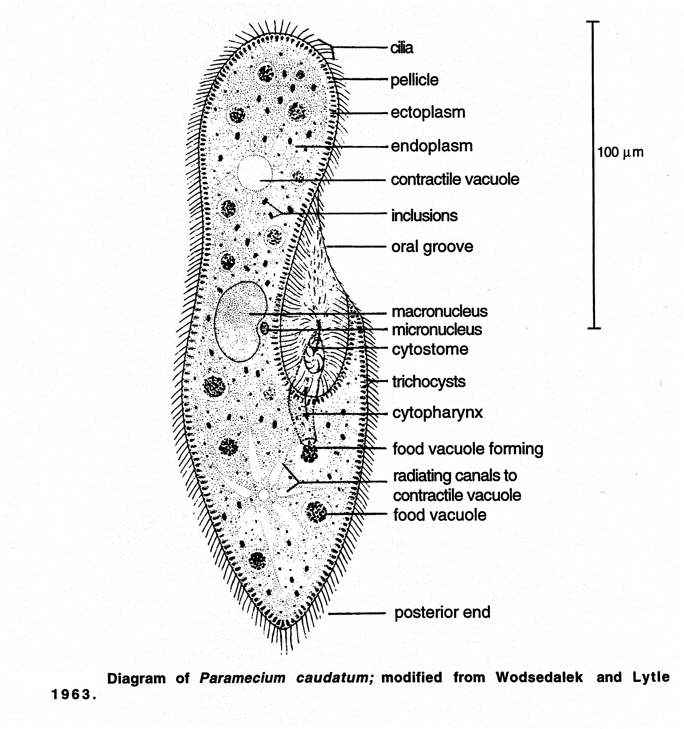
PARAMECIUM: The paramecium is entirely covered in little “hairs” called cilia that it waves in order to swim through the water. Like euplotes, the paramecium sweeps food into its “mouth” with cilia.
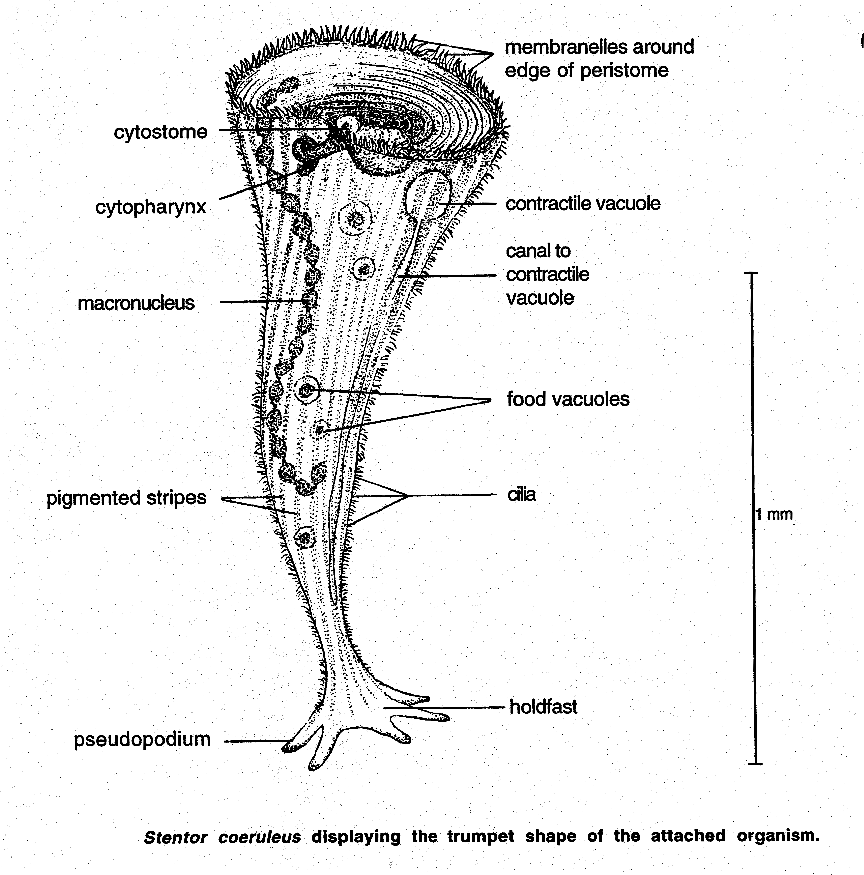
STENTOR: These protists either swim freely (shaped like pears) or attach themselves to particles where they look like the picture above. They move mainly with cilia. When attached, the stentor eats by creating a big funnel as shown above. It uses its cilia to create a whirlpool that sucks the food down its “mouth” (think of a flushing toilet!)
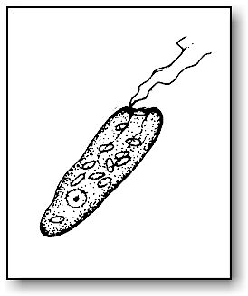
CHILOMONAS: These small, colorless protists also move by means of a flagella. They are a favorite snack of amoebae and other larger protists!
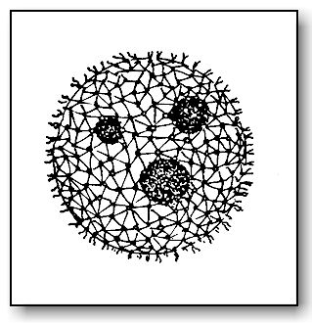
VOLVOX: These protists are actually individual cells of algae that have formed a spherical (round) colony. Each volvox colony can contain over 500 cells that cling to the hollow ball of mucilage. Amazingly, each cell has flagella that will whip in the same direction as others to propel the volvox through the water! The balls you see inside of the volvox are actually daughter colonies that have formed from one cell inside of the colony. Volvox can reproduce both sexually and asexually. Eventually when the mother colony breaks apart the daughters will become their own free colonies. From the color, can you guess how they get food?

Illustration References:

All illustrations were used with permission and information obtained from:
Ecklund, PR and JC Glase,. 2000. Protista. In: Glase JC, Ecklund PR, editors. Investigative biology. Ithaca, NY: BioG 103-104, Cornell U; p.207-234 and Lab Instructor’s Manual (Rotifers).
With the exception of illustrations used with permission from:
Chilamonas and Volvox: http://www.microscope-microscope.org/applications/pond-critters/protozoans/mastigophora/mastigophora.htm
And information on Volvox:
http://www.microscopy-uk.org.uk/mag/indexmag.html?http://www.microscopy-uk.org.uk/mag/art97b/volvoxms.html

This material was developed through the Cornell Science Inquiry Partnership program (http://csip.cornell.edu), with support from the National Science Foundation’s Graduate Teaching Fellows in K-12 Education (GK-12) program (DUE # 0231913 and # 9979516) and Cornell University. Any opinions, findings, and conclusions or recommendations expressed in this material are those of the author(s) and do not necessarily reflect the views of the NSF.
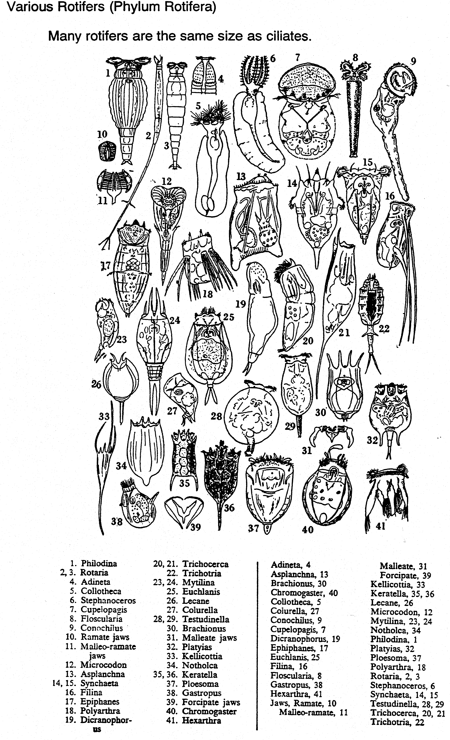
ROTIFERS: These creatures are NOT protists but are actually animals like us. Though they have many cells, they can be smaller than some of the one-celled protists! There are many different types that have interesting ways of moving. Above are pictures of several types.

